 JIANGSU SOHO VIETNAM CO . , LTD
STREET LED LIGHTING BETTER LIGHTING
Add:No.3, Cau Buou Commercial Centre, Ta Thanh Oai, Thanh Tri, Hanoi
E: soholedlighting@gmail.com T:0934 422389 www.denchieusangcongtrinh.com.vn

Quotation for LED street light Better Lighting
Báo giá đèn đường LED Better Lighting

NEW  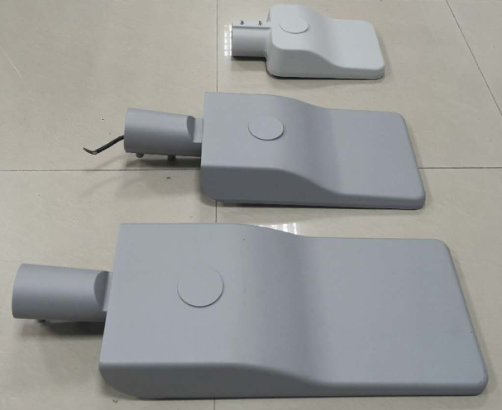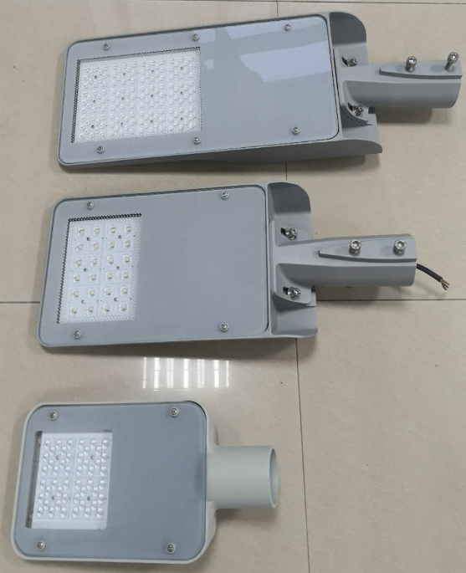  SH-BTLED-1802B-30W/40W/50W/60W  （we have patent for this new product） | Power: 30-60W  LED chip brand: LUMILEDS 3030 chip  LED chip quantity: 36-72 pcs  Color temperature: 3000-6500K  CRI: >70  Average lumen: 115 lm/W  Driver brand: INVENTRONICS  IP rating: IP66  IK rating: IK08  Fitting size: 408*244*74 MM  Warranty: 5 years  REMARK:  - this model is economic design, bottom body only with tempered super-white glass  - we have two kind of spigot : small one is for 38-50MM pole, big one is for 60mm pole  - PCB area is 8mm thick, so we can drill any hole  - according to your different PCB design | 30W:USD 49/PC  (36PCS CHIP)  40W:USD 52/PC  (48PCS CHIP)  50W: USD 61/PC  (60PCS CHIP)  60W: USD 64/PC  (72PCS CHIP)  Empty fitting without PCB and lens: USD27 /pc
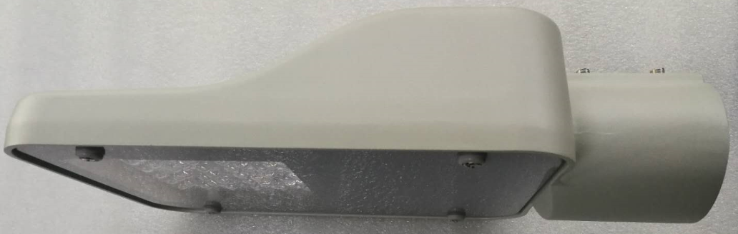  NEW  SH-BTLED-1802C-10W/20W/30W/40W  （we have patent for this new product） | Power: 10-40W  LED chip brand: LUMILEDS 3030 chip  LED chip quantity: 24-48 pcs  Color temperature: 3000-6500K  CRI: >70  Average lumen: 110 lm/W  Driver brand: Dongling (Chinese brand)  IP rating: IP66  IK rating: IK08  Fitting size: 345*195*83 MM  Warranty: 3 years  REMARK:  - this model is economic design, bottom body only with tempered super-white glass  - PCB area is 8mm thick, so we can drill any hole according to your different PCB design | 10W:USD 32/PC  (24PCS CHIP)  20W:USD 34/PC  (24PCS CHIP)  30W:USD 38/PC  (36PCS CHIP)  40W:USD 42/PC  (48PCS CHIP)  Empty fitting without PCB and lens: USD21 /pc
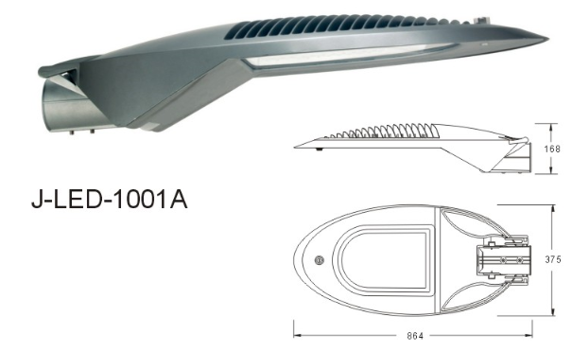  SH-J-LED-1001A | LED chip brand: LG 3535 chip  Color temperature: 3000-6500 K  CRI: >70  Driver brand: PHILIPS  IP rating: IP66  IK rating: IK08  Fitting size:864*375*168mm  Warranty: 5 years | 120W: USD 142/PC  （64PCS CHIP）  150W: USD 155/PC  （80PCS CHIP）  180W: USD 162/PC  （80PCS CHIP）  Empty fitting without PCB and lens: USD71 /pc
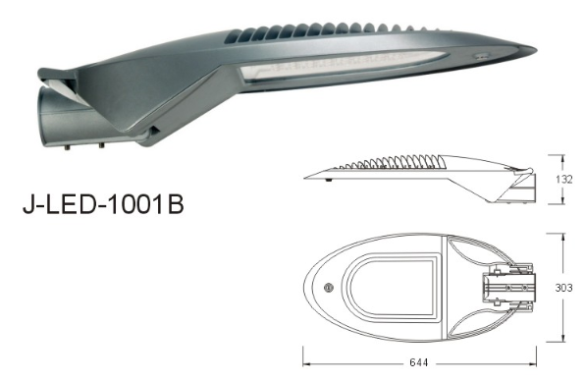  SH-J-LED-1001B | LED chip brand: LG 3535 chip  Color temperature: 3000-6500 K  CRI: >70  Driver brand: PHILIPS  IP rating: IP66  IK rating: IK08  Fitting size:644*303*132 mm  Warranty: 5 years | 60W: USD 100/PC  （30PCS CHIP）  90W: USD 116/PC  （54PCS CHIP）  Empty fitting without PCB and lens: USD48 /pc
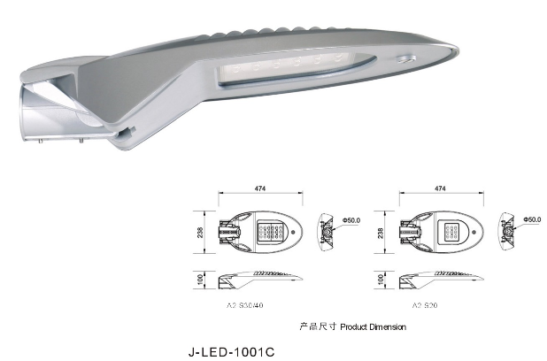  SH-J-LED-1001C | LED chip brand: LG 3535 chip  Color temperature: 3000-6500 K  CRI: >70  Driver brand: SOSEN  IP rating: IP66  IK rating: IK08  Fitting size:474*238*100 mm  Warranty: 5 years | 30W: USD 49/PC  （16PCS CHIP）  50W: USD 63/PC  （32PCS CHIP）  Empty fitting without PCB and lens: USD25 /pc
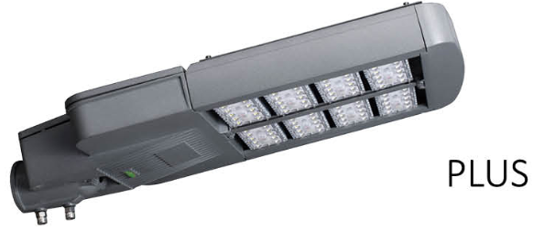  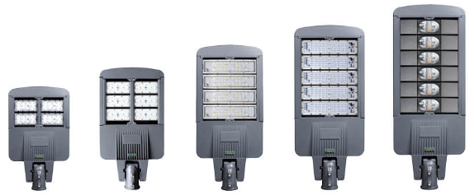  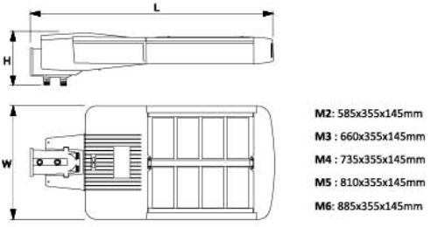  SH-BTLED-1604 | LED chip brand: LUMILEDS 3030 chip  Lens: 1*63pcs , max for 6*63=378pcs  LED module: 1/2/3/4/5/6 pcs  Color temperature: 3000-6500K  CRI: >70  Average lumen: 120 lm/W  Driver brand: PHILIPS  SPD: 10KV+10KA  IP rating: IP66  IK rating: IK09  Warranty: 5 years | 100W: USD 112/PC  （2pcs LED module）  150W: USD 135/PC  （3pcs LED module）  200W: USD 165/PC  （4pcs LED module）  250W: USD 196/PC  （5pcs LED module）  Empty fitting without LED module: USD42/46/50/55/59 For M2/M3/M4/M5/M6

